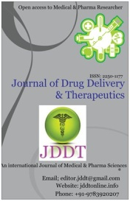
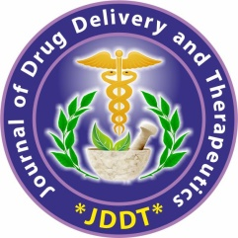
Available online on 15.04.2021 at http://jddtonline.info
Journal of Drug Delivery and Therapeutics
Open Access to Pharmaceutical and Medical Research
© 2011-21, publisher and licensee JDDT, This is an Open Access article which permits unrestricted non-commercial use(CC By-NC), provided the original work is properly cited
Open Access Full Text Article  Research Paper
Development and Validation of Q-Absorbance Ratio by UV-Spectrophotometric Method for Simultaneous Estimation of Metformin and Empagliflozin in Bulk and Combined Dosage Form
Pushpendra Sharma, Srinivasarao Kosanam*, Surendra Singh Rao
Department of Science, Sri Satya Sai University of Technology and Medical Sciences, Sehore- (MP) - 466001

Article Info:  _________________________________________  Article History:  Received 04 Feb 2021  Review Completed 14 March 2021  Accepted 19 March 2021  Available online 15 April 2021    ___________________________________________________________  Cite this article as:  Sharma P, Kosanam S, Rao SS, Development and Validation of Q-Absorbance Ratio by UV-Spectrophotometric Method for Simultaneous Estimation of Metformin and Empagliflozin in Bulk and Combined Dosage Form, Journal of Drug Delivery and Therapeutics. 2021; 11(2-s):14-18 DOI: http://dx.doi.org/10.22270/jddt.v11i2-s.4624 _________________________________________  *Address for Correspondence:  Srinivas Kosanam, Research Scholar, Department of Science, Sri Satya Sai University of Technology & Medical Sciences, Sehore- (MP) - 466001 | Abstract  ______________________________________________________________________________________________________  Advantages of simultaneous stability studies are the identification of new degradation products, to understand mutual induction and/or inhibition of rates of degradation and to analyze the degradation products of both drugs. Various ultraviolet spectroscopic and high performance liquid chromatographic assay methods were reported for the estimation of metformin, sitagliptin, pioglitazone, glimepiride and simvastatin individually and in combination with other drugs. All the above reported methods were based on the estimation of metformin, sitagliptin, pioglitazone, glimepiride and simvastatin alone or in combination with other drugs. The degradation products were generated and successfully separated by the developed and validated high performance liquid chromatographic methods for the estimation of the selected anti-diabetic drug combinations. The aim of the study was to develop and validate of Q-Absorbance Ratio UV-Spectrophotometric Method for Simultaneous Estimation of Metformin and Empagliflozin in Bulk and Combined Dosage Form.  Keywords: Metformin, Method Development, Validation, Empagliflozin, UV-Spectrophotometer.

INTRODUCTION:
Type 2 Diabetes mellitus (T₂DM) is the most prevalent metabolic disease worldwide. Inadequate management and control of hyperglycemia in patients with T₂DM may lead to the risk of developing complications over the long term due to chronic and progressive nature of the disease arising from pathophysiology of beta-cell dysfunction, insulin resistance and increased hepatic glucose output¹⁻³. Patients with T₂DM often require a combination of therapeutic agents in order to achieve glycemic control over the long term. Fixed-dose combination (FDC) therapies have been shown to improve adherence by reducing costs, pill burden, and the complexity of treatment regimen. A treatment approach with a FDC that includes combination of anti-diabetic medications could be used to obtain adequate glycemic control in patients with type 2 diabetes. A combined formulation consisting of metformin, sitagliptin and glimepiride in a single tablet would potentially offer increased patient convenience and subsequent potential for increased therapeutic compliance and can be studied for the treatment of adults with inadequately controlled T₂DM to improve glycemic control⁴⁻⁷. A clinical trial was conducted for evaluation of sitagliptin in combination with metformin and sulfonylurea. The aim of that clinical trial protocol was to determine the non-inferiority of the effectiveness of sitagliptin compared to a control group of patients treated with thiazolidinedione as add-on therapy; in low-income ethnic minority type 2 diabetic patients who are failing to maintain adequate control with maximal doses of metformin and a sulfonylurea agent⁸⁻¹². The aim of the present research work was to develop and validate of Q-Absorbance Ratio UV-Spectrophotometric Method for Simultaneous Estimation of Metformin and Empagliflozin in Bulk and Combined Dosage Form.
MATERIALS AND METHODS
Reagents and Apparatus: Metformin and Empagliflozin were received as gift sample form Glenmark pharmaceutical ltd, Mahape (Mumbai), India. Methanol and Water were used of HPLC grade and purchased from Fisher Scientific, India. Potassium dihydrogen phosphate buffer was purchased from Sigma-Aldrich Company, India. A double beam UV-Visible spectrophotometer, PerkinElmer, UK, with software lab solution 1.86 and 1 cm quartz cell, was used for the analysis. Standard stock solution (100 g/mL) of Metformin and Empagliflozin were prepared separately by dissolving accurately weighed 10mg of individual drug in 100 mL volumetric flask and diluting up to the mark with methanol.
Preparation of Working Standard Stock Solutions: 1ml from Metformin and 1 ml from Empagliflozin stock solutions were taken into a 10 ml volumetric flask and made up to mark with Methanol. (Metformin and Empagliflozin-10 µg/ml each respectively).

Preparation of Sample solution: Sample stock solution: Standard laboratory mixture equivalent to 10 mg of Metformin and Empagliflozin was diluted up to 100 ml with methanol. (Metformin and Empagliflozin-100 µg/ml each). This solution was filtered through Whatmann filter paper. -Spectrophotometric Method for Simultaneous Estimation of Metformin and Empagliflozin in Bulk and Combined Dosage Form Working sample preparation: 1 ml of above stock solution was diluted to 10 ml with methanol. (Metformin and Empagliflozin-10µg/ml each).

Determination of Iso-absorptive Point and Wavelength of Maximum Absorbance (𝜆max): Solutions of 10µg/mL of Metformin and Empagliflozin were scanned in the range of 200 nm to 400 nm against methanol as blank. The method involved Q-absorption ratio analysis using two wavelengths obtained by the overlay spectrum of the Metformin and Empagliflozin; with one being the maximum absorbance wavelength of Empagliflozin (225 nm, 𝜆2) and the other being the iso-absorptive point of both drugs (250 nm, 𝜆1).

Preparation of Sample Solutions from Standard Stock Solution: The sample solutions of various concentrations were prepared from the standard stock solution by diluting aliquots of working stock solutions appropriately.

Calibration Curve (Linearity): The linearity response was determined by analyzing six independent levels of calibration curve in the range of 5-17.5 μg/mL for each of Metformin and Empagliflozin respectively (n=3). Accurately measured stock solutions of Metformin and Empagliflozin (5.0, 7.5, 10.0, 12.5, 15.0 and 17.5 mL) were transferred to two separate series of 100 mL volumetric flask and diluted up to the mark with methanol. The absorbance of both solutions was taken at their respective 𝜆max and at iso-absorptive point. The calibration curves were constructed by plotting concentration against absorbance where each data point was an average of three determinations.

Estimation of Standard Laboratory Mixture using proposed method: The absorptivity coefficient of both the drugs was determined. The individual concentration Method Validation of Metformin and Empagliflozin was determined using the following equations:
𝐶_{Metformin =} (𝑄𝑀 – 𝑄𝑌) x 𝐴1/ (𝑄x – 𝑄𝑌) x ax1
𝐶_{Empagliflozin}= (𝑄𝑀 – 𝑄X) x 𝐴1 / (𝑄Y – 𝑄X) x ay1
where, 𝑄𝑀 = 𝐴2/𝐴1, 𝑄𝑋 = 𝑎𝑋2/𝑎𝑋1, and 𝑄𝑌 = 𝑎𝑌2/𝑎𝑌1; 𝐴1 and 𝐴2 are the absorbance of the mixture at 250 nm and 240 nm respectively; 𝑎𝑋1 and 𝑎𝑌1 are absorptivities at 250 nm (𝜆1); 𝑎𝑋2 and 𝑎𝑌2 are absorptivities at 225 nm (𝜆2).

Method Validation

Linearity and Range: Linearity, consisting of the basic elements input → converter → output, is the assumption that there is a straight-line relationship between the input (𝑥) and output (𝑦) variables that can be written mathematically by the expression 𝑦 = 𝑓(𝑥), if the straight-line crosses through the origin or by the expression 𝑦 = 𝑓(𝑥) + 𝛿 , if the straight line does not cross through the origin.
The linear range corresponds to the valid interval of functional dependence of the signal on concentration or mass that assumes homoscedasticity of the measurements over the linear range. The linear response of Metformin and Empagliflozin was determined by analyzing six independent levels of the calibration curve in the range of 5–17.5 𝜇g/mL.
Precision: ICH guidelines define the term precision as the closeness of agreement between quantity values obtained by replicate measurements of a quantity under specified conditions ^{[11]}. Assessing the precision implies expressing numerically the random error or the degree of dispersion of a set of individual measurements by means of the standard deviation, the variance, or the coefficient of variation.
Repeatability: It is the concordance of a series of measurements of the same quantity when the experiments are conducted under same conditions (analyst, apparatus, instrument, and day) in a rapid succession. Standard solution of Metformin and Empagliflozin (10 𝜇g/mL each) was prepared and analyzed six times as per the proposed method.

Intermediate Precision: It is the concordance of a series of measurements of the same quantity when the experiments are conducted within the same laboratory under different conditions (analyst, apparatus, instrument, and day). Standard solution of Metformin and Empagliflozin (10 𝜇g/mL each) was prepared and analyzed as per the proposed method.

Accuracy (%Recovery): The accuracy of an analytical procedure expresses the closeness of agreement between the value that is accepted either as a conventional true value or an accepted reference value and the value found. The recovery experiments were carried out in triplicate by spiking previously analyzed samples with three different concentrations of standards.

Limit of Detection (LOD) and Limit of Quantification (LOQ): The detection limit of an individual analytical procedure is the lowest amount of analyte in the sample that can be detected but not necessarily quantitated as an exact value. The quantitation limit of an individual analytical procedure is the lowest amount of analyte in the sample that can be quantitatively determined with suitable precision and accuracy. The LOD and LOQ of the proposed method were determined by using calibration curve:
LOD = 3.3 x [Standard deviation of the response (Y-intercept of calibration curve)/ Slope of the calibration curve]
LOQ = 10 x [Standard deviation of the response (Y-intercept of calibration curve)/ Slope of the calibration curve]

Sandell’s Sensitivity: Sandell’s sensitivity, the concentration of the analyte (in 𝜇g/mL or 𝜇g/cm²) that will give an absorbance of 0.001 in a cell of path length 1cm, was calculated. It gives valuable information regarding sensitivity of the method.

RESULTS AND DISCUSSION
The solutions of 10𝜇g/mL of both Metformin and Empagliflozin were analyzed and the 𝜆max was found to be 225 nm and 240 nm respectively. Two iso-absorptive points: 230 nm and 250 nm were obtained by overlaying the spectra and the iso-absorptive point 250 nm was selected for further analysis.
The calibration curve of Metformin and Empagliflozin individually and the mixture of both drug at 225 nm (𝜆1) and 250 nm (𝜆2) were plotted (Figures 1 and 2). The relationship between the absorbance and the concentration of Metformin and Empagliflozin was linear in the range of 5–17.5𝜇g/mL at both wavelengths 225nm and 250nm. The representative linear equations were calculated by the least squares method and the correlation coefficients were linear (Table 1). Evaluation of repeatability and intermediate precision was done and coefficients of variation (CV) or percent relative standard deviation (%RSD) values were <2%, indicating good precision (Table 2). Accuracy of the proposed method was calculated by percent recovery in standard addition method. Accuracy ranged between 100.28 and 104.24% for Metformin and 96.88 and 104.06% for Empagliflozin (Table 3). The limit of detection (LOD) of Metformin and Empagliflozin at iso-absorptive point (250 nm) was 0.106 𝜇g/mL and 0.078𝜇g/mL; at 225 nm, LOD was 0.186𝜇g/mL and 0.211 𝜇g/mL for Metformin and Empagliflozin respectively. The limit of quantification (LOQ) of Metformin and Empagliflozin at iso-absorptive point (250 nm) was 0.321 𝜇g/mL and 0.238𝜇g/mL; at 225 nm, LOQ was 0.563𝜇g/mL and 0.639𝜇g/mL for Metformin and Empagliflozin, respectively.
Sandell’s sensitivity was 0.0347 and 0.0348 𝜇g/cm² at 250 nm and 0.022 and 0.035 𝜇g/cm² Simultaneous Estimation of Metformin and Empagliflozin in Bulk and Combined Dosage
Form at 225 nm for Metformin and Empagliflozin, respectively. Various validation parameters are summarized in Table 4.

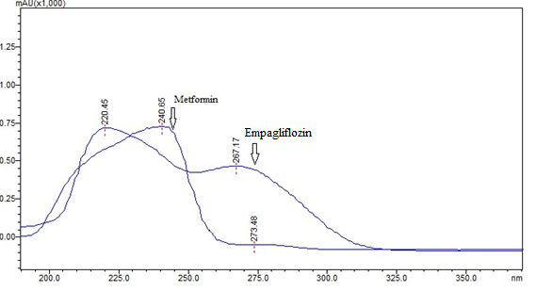
Figure 1: UV Scan of Metformin and Empagliflozin Showing Iso-Absorptive Points
Table 1: Calibration Points of Standard Curve with Absorbance and Concentration of the Solution
Concentration of the solution (µg/mL) | Absorbance at 225 nm |  | Absorbance at 250 nm
Concentration of the solution (µg/mL) | Metformin | Empagliflozin | Metformin | Empagliflozin
5 | 0.421 | 0.288 | 0.095 | 0.19
7.5 | 0.6315 | 0.432 | 0.242 | 0.278
10 | 0.842 | 0.576 | 0.422 | 0.358
12.5 | 1.0525 | 0.72 | 0.655 | 0.525
15 | 1.263 | 0.864 | 0.882 | 0.655
17.5 | 1.431 | 1.008 | 1.185 | 0.789

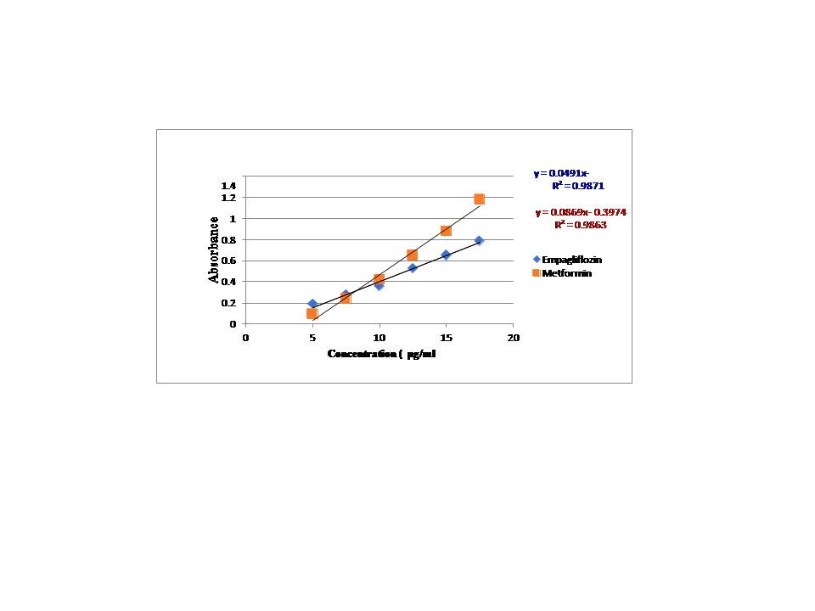
Figure 2: Calibration Curves of Metformin and Empagliflozin at 250 nm

Figure 3: Calibration Curves of Metformin and Empagliflozin at 225 nm

Table 2: Result of Precision
Precision |  | At 225 nm  At 225 nm |  |  |  | At 250 nm
 |  | %Estimation of |  |  |  | %Estimation of
 | Conc of the  solution  (µg/mL) | Met(n=6) | %  RSD | Empa  (n = 6 | %  RSD | Met(n=6) | %  RSD | Empa  (n = 6) | %  RSD
Repeatability | 10 | 0.514 | 0.502 | 0.356 | 0.674 | 0.526 | 0.288 | 0.424 | 0.50
Intra-day Precision | 5 | 0.193 | 1.371 | 0.146 | 1.014 | 0.192 | 1.041 | 0.095 | 1.05
Intra-day Precision | 10 | 0.515 | 0.224 | 0.525 | 0.397 | 0.356 | 0.429 | 0.424 | 0.59
Intra-day Precision | 17.5 | 1.205 | 0.332 | 1.254 | 0.319 | 0.789 | 0.194 | 1.183 | 0.25
Inter-day Precision | 5 | 0.192 | 1.826 | 0.147 | 1.041 | 0.191 | 1.597 | 0.095 | 1.05
Inter-day Precision | 10 | 0.514 | 0.583 | 0.525 | 0.397 | 0.355 | 0.988 | 0.424 | 0.59
Inter-day Precision | 17.5 | 1.201 | 0.584 | 1.254 | 0.319 | 0.784 | 0.575 | 1.183 | 0.25

Table 3: Results of Recovery Studies of Metformin
Conc. Level (%) | Sample amount  (μg/ml) | Amount  Added  (μg/ml) | Amount  Recovered  (μg/ml) | % Recovery | % Mean Recovery ± S.D
80 % | 5 | 4 | 4.17 | 104.25 | 102.13 ± 1.898
80 % | 5 | 4 | 4.061 | 101.53 | 102.13 ± 1.898
80 % | 5 | 4 | 4.024 | 100.60 | 102.13 ± 1.898
100 % | 5 | 5 | 5.212 | 104.24 | 102.14 ± 2.110
100 % | 5 | 5 | 5.108 | 102.16 | 102.14 ± 2.110
100 % | 5 | 5 | 5.001 | 100.02 | 102.14 ± 2.110
120 % | 5 | 6 | 6.113 | 101.88 | 101.29 ± 0.876
120 % | 5 | 6 | 6.102 | 101.70 | 101.29 ± 0.876
120 % | 5 | 6 | 6.017 | 100.28 | 101.29 ± 0.876

Table 4: Results of Recovery Studies of Empagliflozin
Conc. Level (%) | Sample amount  (μg/ml) | Amount  Added  (μg/ml) | Amount  Recovered  (μg/ml) | %  Recovery | % Mean Recovery ± SD
80 % | 5 | 4 | 4.069 | 101.73 | 100.41 ±3.093
80 % | 5 | 4 | 3.875 | 96.88 | 100.41 ±3.093
80 % | 5 | 4 | 4.105 | 102.63 | 100.41 ±3.093
100 % | 5 | 5 | 5.203 | 104.06 | 102.19 ± 1.804
100 % | 5 | 5 | 5.102 | 102.04 | 102.19 ± 1.804
100 % | 5 | 5 | 5.023 | 100.46 | 102.19 ± 1.804
120 % | 5 | 6 | 6.025 | 100.42 | 102.01 ± 1.559
120 % | 5 | 6 | 6.212 | 103.53 | 102.01 ± 1.559
120 % | 5 | 6 | 6.124 | 102.07 | 102.01 ± 1.559

Table 5: Summary of Regression Characteristics and Validation Parameters
Parameters | Metformin |  | Empagliflozin
Parameters | 225 nm | 250 nm | 225 nm | 250 nm
Beer’s law limit (µg/mL) | 5 – 17.5 | 5 – 17.5 | 5 – 17.5 | 5 – 17.5
Absorptivity | 0.05 | 0.035 | 0.05 | 0.04
Regression equation (y = mx +c) | y=0.0797x -0.2418 | y=0.0491x- 0.0861 | y= 0.0897x -  0.3586 | y = 0.0869x -  0.3974
Slope (m) | 0.0797 | 0.0861 | 0.3586 | 0.0869
Intercept (c) | 0.2418 | 0.0491 | 0.0897 | 0.3974
Regression coefficient (r² ) | 0.98222 | 0.98704 | 0.98886 | 0.98727
SD of slope) | 0.017 | 0.031 | 0.043 | 0.043
LOD (µg/mL | 0.747 | 1.567 | 1.581 | 1.581
LOQ (µg/mL) | 2.265 | 4.748 | 4.791 | 4.791
Sandell’s sensitivity (µg/cm²) | 0.0356 | 0.0347 | 0.0229 | 0.0348

CONCLUSION:
The UV spectrophotometric Q-absorption ratio method was developed and validated for the simultaneous analysis of Metformin and Empagliflozin. The results together established that the method is simple, accurate, precise, reproducible, rapid, and sensitive. The method can be applied successfully and economically for the simultaneous estimation of Metformin and Empagliflozin in bulk and in the synthetic laboratory mixture and also for the quantitation of generic equivalents in pharmaceutical industries.
ACKNOWLEDGEMENTS:
The authors wish to thank the management of Sai Laboratories Limited for supporting this work. Authors wish to acknowledge the Analytical research group for providing the necessary facilities for our research and also wish to thanks colleagues in Validation division of analytical research for their co-operation in carrying out this work.
LIST OFABBREVIATIONS:
No. | Number
NA | Not Applicable
BLQ | Below limit of Quantification
LOQ | Limit of Quantitation
SD | Standard Deviation
RSD | Relative Standard Deviation
LOD | Limit of Detection
Imp | Impurity
Unk | Unknown
Max | Maximum
Hrs | Hours
HPLC | High performance Liquid Chromatography
RSD | Relative Standard Deviation
RRT | Relative retention time
S/N | Signal to Ratio
REFERENCES:
- Hasunuma Y, Matsuura E, Makita Z, Katahira T, Nishi S, Koike T. Involvement of b2-glycoprotein I and anti-cardiolipin antibodies in oxidatively modified low-density lipoprotein uptake by macrophages. Clin Exp Immunol 1997; 107:569-73.
- Dhaliya SA, Surya AS, Dawn VT, Betty C, Arun K, Sunil C. A review of hyperlipidemia and medicinal plants. IJAPS BMS 2013; 2:219-37.
- Lipinski CA, Lombardo F, Dominy BW, Feeney PJ. Experimental and computational approaches to estimate solubility and permeability in drug discovery and development settings. Adv Drug Delivery Rev 1997; 23:3-25.
- Shelke S, Shahi S, Jadhav K, Dhamecha D, Tiwari R, Patil H. Thermoreversible nano-ethosomal gel for the intranasal delivery of Eletriptan hydrobromide. J Mater Sci Mater Med 2016; 27:1-3.
- Shelke S, Shahi S, Jalalpure S, Dhamecha D. Poloxamer 407 based intranasal thermoreversible gel of zolmitriptanloaded nano liposomes: formulation, optimization, evaluation and permeation studies. J Liposome Res 2016; 26:313-23.
- Gursoy RN, Benita S. Self-emulsifying drug delivery systems for improved oral delivery of lipophilic drugs. Biomed Pharmacother 2004; 58:173-82.
- Nelson RH. Hyperlipidemia as a risk factor for cardiovascular disease. Prim Care 2013; 40:195-211.
- Rohilla A, Dagar N, Rohilla S, Dahiya A, Kushnoor A. Hyperlipidemia–a deadly pathological condition. Int J Curr Pharm Res 2012; 4:15-8.
- Castelli WP. The triglyceride issue: a view from Framingham. Am Heart J 1986; 112:432-7.
- Rohilla AN, Dagar N, Rohilla S, Dahiya A, Kushnoor A. Hyperlipidemia a deadly pathological condition. Int J Curr Pharm Res 2012; 4:15-8.
- Nakamura K, Miyoshi T, Yunoki K, Ito H. Postprandial hyperlipidemia as a potential residual risk factor. J Cardiol 2016; 67:335-9.
- Goldstein JL, Schrott HG, Hazzard WR, Bierman EL, Motulsky AG. Hyperlipidemia in coronary heart disease II. Genetic analysis of lipid levels in 176 families and delineation of a new inherited disorder, combined hyperlipidemia. J Clin Invest 1973; 52:1544.

